# **Acropolis Institute of Technology & Research**

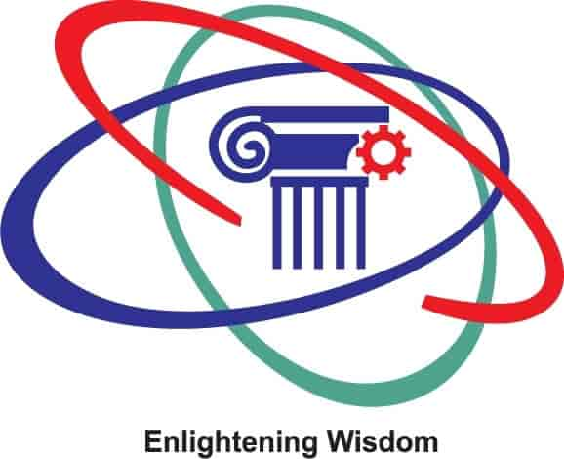

Subject: Database Management System (CY-405)

Name: Anushka Bagwan

Enrollment no: 0827CY221013

Branch: CY(Cyber Security)

Semester: 4th (2nd Year)

Submitted to: Prof.Nidhi Nigam

**INDEX**

|  |  |  |  |  |
| --- | --- | --- | --- | --- |
| S.No | Experiment | Date of Experiment | Date of submission | Grade |
| 1. | To study of DBMS and RDBMS,its characteristics and database softwares. | 6/03/24 |  |  |
|  |  |  |  |  |
|  |  |  |  |  |
|  |  |  |  |  |
|  |  |  |  |  |
|  |  |  |  |  |
|  |  |  |  |  |
|  |  |  |  |  |

**LAB 1 – INTRODUCTION TO DBMS**

Objective: To study of DBMS and RDBMS.

DBMS: Database Management System is a software or technology used to manage data from a database. Some popular databases are MySQL, Oracle, MongoDB, etc. DBMS provides many operations e.g. creating a database, Storing in the database, updating an existing database, delete from the database. DBMS is a system that enables you to store, modify and retrieve data in an organized way. It also provides security to the database.

CHARACTERISTICS OF DBMS:

* A database management system is able to store any kind of data in a database.
* The database management system has to support ACID (atomicity, consistency, isolation, durability) properties.
* The Database management system allows so many users to access databases at the same time.
* Backup and recovery are the two main methods which allow users to protect the data from damage or loss.
* It also provides multiple views for different users in a single organization.
* It follows the concept of normalization which is helpful to minimize the redundancy of a relation.

TYPES OF DBMS

## **1) Centralized Database**

It is the type of database that stores data at a centralized database system. It comforts the users to access the stored data from different locations through several applications.

## **2) Distributed Database**

Unlike a centralized database system, in distributed systems, data is distributed among different database systems of an organization. These database systems are connected via communication links. Such links help the end-users to access the data easily.

## **3) Relational Database**

This database is based on the relational data model, which stores data in the form of rows(tuple) and columns(attributes), and together forms a table(relation).

## **4) NoSQL Database**

Non-SQL/Not Only SQL is a type of database that is used for storing a wide range of data sets. It is not a relational database as it stores data not only in tabular form but in several different ways.

## **5) Cloud Database**

A type of database where data is stored in a virtual environment and executes over the cloud computing platform. It provides users with various cloud computing services (SaaS, PaaS, IaaS, etc.) for accessing the database.

## **6) Object-oriented Databases**

The type of database that uses the object-based data model approach for storing data in the database system. The data is represented and stored as objects which are similar to the objects used in the object-oriented programming language.

RDBMS:

**RDBMS stands for relational database management system and it is a software system and it is a software system that is used to store only data in the form of tables.Data is handled and stored in rows and columns ,which is reffered to as tuples and attributes.**

DIFFERENCE between DBMS AND RDBMS:

|  |  |
| --- | --- |
| **DBMS** | **RDBMS** |
| Data is stored in a database management system (DBMS) as a file | Tables are used to store information |
| Data is stored in a database management system (DBMS) in either a navigational or hierarchical format | RDBMS employs a tabular format, with column names as headers and associated data as rows |
| Only a single user is supported by the DBMS | It may be used by numerous people |
| Software and hardware requirements are minimal | Higher hardware and software requirements are required |
| Normalization is not supported by DBMS. | A relational database management system (RDBMS) can be normalised |
| Distributed databases are not supported by DBMS | Distributed databases are supported by RBMS |
| The DBMS system is mostly used to manage tiny amounts of data | The RDBMS database is built to manage a vast volume of data |

Data softwares used in DBMS

* [MySQL](https://www.guru99.com/sql.html)
* [Microsoft Access](https://www.guru99.com/ms-access-tutorial.html)
* Oracle
* [PostgreSQL](https://www.guru99.com/postgresql-tutorial.html)
* dBASE
* FoxPro
* [SQLite](https://www.guru99.com/sqlite-tutorial.html)
* IBM DB2
* LibreOffice Base
* [MariaDB](https://www.guru99.com/mariadb-tutorial-install.html)
* Microsoft [SQL Server](https://www.guru99.com/ms-sql-server-tutorial.html)